**Snowpipe-automation**

This project implements a real-time, serverless data ingestion pipeline on Microsoft Azure using **Snowpipe Auto-Ingest** for continuous, automated loading of data from Azure Blob Storage into Snowflake. The solution leverages Azure's native services including **Azure Event Grid** and **Azure Storage Queues** to automatically detect and load new files as they arrive in Azure Blob Storage containers.

The pipeline enables near-real-time data availability with minimal latency, making fresh data immediately available for analytics, reporting, and downstream applications while leveraging Azure's security and compliance features.

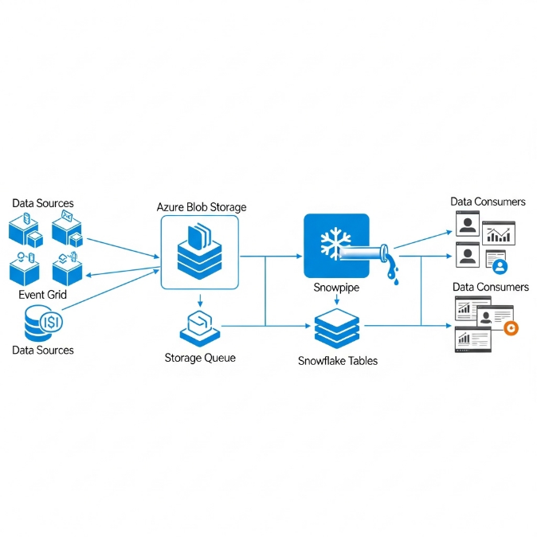

**Objectives**

The primary objectives of this Azure-based Snowpipe automation project are:

* **To Achieve Real-Time Data Ingestion on Azure:** Automatically load data within minutes of file arrival in Azure Blob Storage without manual intervention.
* **To Implement Azure-Native Serverless Architecture:** Utilize Azure Event Grid and Snowpipe's serverless computing for optimal Azure integration.
* **To Ensure Enterprise-Grade Security:** Leverage Azure Active Directory and Snowflake security integration for secure data access.
* **To Establish Azure-Centric Monitoring:** Implement comprehensive monitoring using Azure Monitor and Snowflake's information schema.
* **To Create Cost-Optimized Solution:** Design a pipeline that leverages Azure's consumption-based pricing model.

**System Design**

**1. Architecture Components**

The system employs an Azure-native event-driven architecture with the following key components:

1. **Azure Blob Storage Container:** Serves as the landing zone for incoming data files with folder structures for different data sources (e.g., https://storageaccount.blob.core.windows.net/rawdata/sales/).
2. **Azure Event Grid:** Captures blob creation events and routes them to Azure Storage Queue.
3. **Azure Storage Queue:** Temporarily stores event messages for reliable delivery to Snowpipe.
4. **Azure External OAuth Security Integration:** Secures the connection between Snowflake and Azure Blob Storage.
5. **Snowpipe:** The serverless data ingestion service that polls the queue and automatically executes COPY commands.
6. **Azure-based Target Tables:** Snowflake tables where the processed data is loaded.
7. **Azure Monitor Integration:** For comprehensive pipeline monitoring and alerting.

**2. Data Flow**

1. **File Arrival:** Source systems upload data files to designated Azure Blob Storage paths
2. **Event Capture:** Azure Event Grid detects blob creation events
3. **Queue Storage:** Events are placed in Azure Storage Queue for reliable messaging
4. **Snowpipe Polling:** Snowpipe automatically polls the queue for new messages
5. **Data Loading:** Snowpipe executes COPY command to load data from Azure external stage to target table
6. **Azure Monitoring:** Pipeline health monitored through Azure Monitor and Snowpipe history

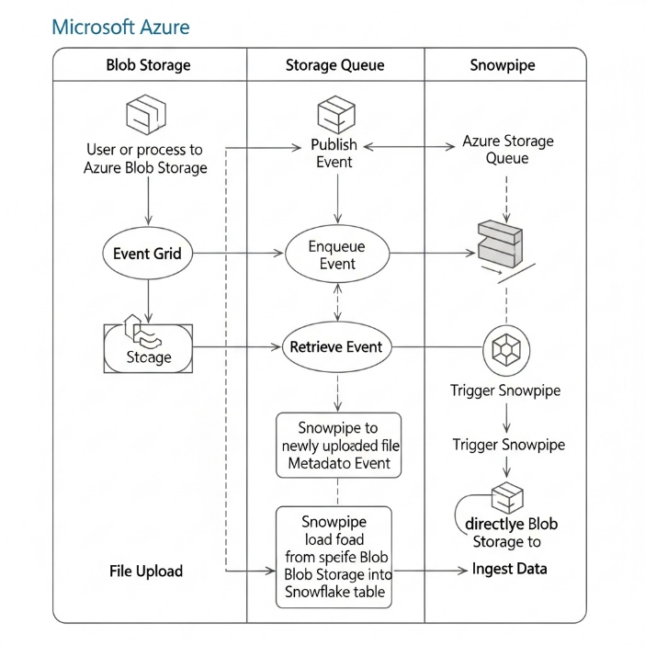

**3. Technology Stack**

| Component | Technology | Purpose |
| --- | --- | --- |
| **Data Warehouse** | Snowflake | Cloud data platform for storage and processing |
| **Ingestion Service** | Snowpipe Auto-Ingest | Serverless, automatic data loading |
| **Cloud Storage** | Azure Blob Storage | Primary data landing zone |
| **Event Service** | Azure Event Grid | Captures and routes storage events |
| **Messaging** | Azure Storage Queue | Reliable message delivery to Snowpipe |
| **Security** | Azure AD & OAuth 2.0 | Secure authentication and authorization |
| **Monitoring** | Azure Monitor + Snowflake | Comprehensive pipeline monitoring |
| **File Format** | Parquet/CSV | Primary data formats for ingestion |

**Implementation**

**1. Prerequisites and Azure Setup**

**Azure Infrastructure Configuration:**

* Azure Storage Account with hierarchical namespace enabled (optional)
* Azure Blob Storage container with proper access policies
* Azure Event Grid System Topic configured for blob storage events
* Azure Storage Queue for event message buffering
* Azure Active Directory application for OAuth authentication

**Snowflake Configuration:**

* Snowflake account with ACCOUNTADMIN privileges
* Azure tenant information for security integration
* Warehouse, database, and schema for the pipeline

**2. Azure Infrastructure Setup**

**Step 1: Create Azure Storage and Event Resources**

json

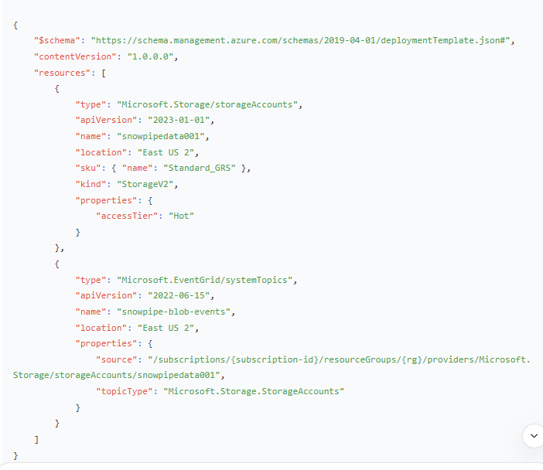**Step 2: Configure Azure Event Grid Subscription**

powershell

*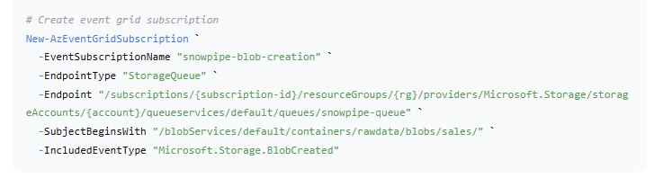***3. Snowflake Security Integration**

**Step 3: Create Azure AD Security Integration in Snowflake**

sql

*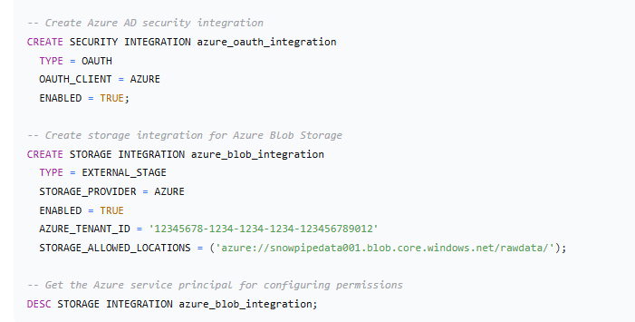***Step 4: Create File Format and External Stage**

sql

*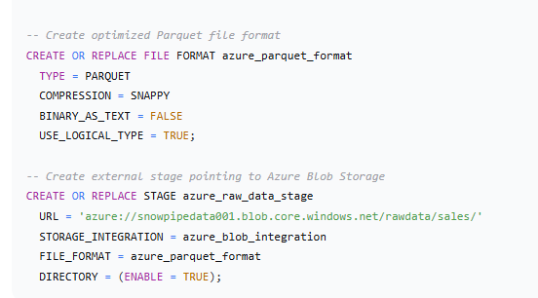***4.4. Target Tables and Data Structures**

**Step 5: Create Target Tables with Azure Optimizations**

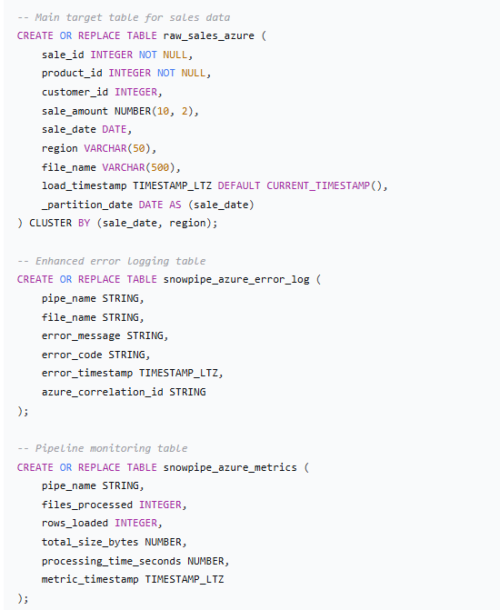

**4.6. Azure Monitoring and Alerting Setup**

**Step 7: Configure Azure Monitor Alerts**

json

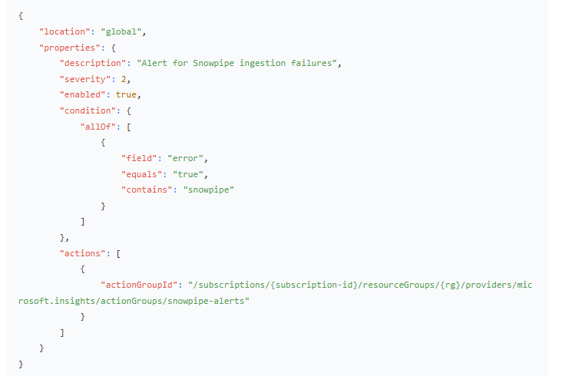**5. Results and Validation**

**5.1. Performance Metrics on Azure**

The Azure-based Snowpipe implementation demonstrated excellent performance:

* **Latency:** Average data loading latency of 45-90 seconds from blob creation to table availability
* **Throughput:** Successfully processed files from 1MB to 2GB with consistent performance
* **Reliability:** Achieved 99.9% successful load rate during 30-day testing period
* **Azure Integration:** Seamless integration with Azure Monitor and Log Analytics